NGO Management

# Project Defination / Summary:

Connecting Goodness is a platform connecting NGOs, Contributors, and donors to drive positive community impact. Inspired by the resilience of a tree, it bridges the gap between those in need and those willing to contribute. With a focus on social welfare, Connecting Goodness enables seamless collaboration for causes like education, healthcare, and disaster relief, supporting NGOs in project management, volunteer mobilization, and donation tracking, while empowering individuals to engage in meaningful service.

# Technology Stack:

|  |  |  |
| --- | --- | --- |
| Front-end | ReactJS | For building dynamic, responsive user interfaces that are platform independent and SPA |
|  | Design framework : Material UI | React component library for modern, customizable UIs. |
|  | HTML, CSS and Bootstrap | for pre-built, responsive UI components. |
|  | JavaScript | for scalable,  high-performance server-side JavaScript. |
| Back-end | NodeJS with Express | for building RESTful APIs and handling server requests. |
| Database | MongoDB | for flexible, scalable NoSQL data storage. |
| Tools | VS studio code | Code editor for writing and debugging with extensions. |
|  | Postman | Tool for testing and automating APIs. |
|  | MongoDB Atlas | Managed cloud service for scalable MongoDB databases. |

|  |  |  |
| --- | --- | --- |
|  | GIT | Version control system for tracking code changes. |

Roles:

1. NGO:
   1. Post Projects
   2. Manage Contributor
   3. Manage Donors
2. Contributor:
   1. Contributor in Projects
   2. View Profile
   3. Donate
3. Admin:
   1. Verifies NGO
   2. Verifies Contributors

# Project Flow

1. NGO

Step 1: Sign Up and Create Profile

* + Visit the Platform: Go to the Connecting Goodness website.
  + Create an NGO Account: Provide necessary details such as NGO name, contact info, and location.

Step 2: Post a New Project

* + Log In: After successful sign-up, log in using your credentials.
  + Goto Activities page
  + Post activity

Step 3: Manage Existing Projects

* + View Active Projects: Go to “Manage Projects” to see a list of your ongoing, upcoming, and completed projects.
  + Update Project: Edit the project details if needed, or mark it as completed once the project is finished.

Step 4: Manage Donations and Contributors

* + Track Donations: In the “Manage Donations” section, view the total amount raised, individual donor contributions, and transaction history.
  + Communicate with Contributors: Send messages or notifications to Contributors for updates or scheduling.

1. Contributor:

Step 1: Sign Up and Create Profile

* + Visit Connecting Goodness: Go to the website or app and sign up as a contributor.
  + Create Profile: Fill in personal details, including skills, interests, and availability to match you with relevant projects.

Step 2: Browse Available Activities

* + Dashboard: Once logged in, navigate to the Contributor Dashboard.
  + View Projects: Browse through a list of available projects, sorted by category, location, or date.

Step 3: Enrolls for a Project

* + Select Project: Click on a project that interests you to view full details
  + Enroll: Click the “Enroll” button to Enroll for the project.
  + Confirmation: You will receive a confirmation email or notification once your participation is accepted.

Step 4: Track Your Contributions

* + Contributor Dashboard: Monitor the number of hours Contributed, donations contributed, updates on the project, and any feedback from NGOs.

1. Admin:

Step 1: Admin Login

* + Access Admin Dashboard: Log in using your Admin credentials to enter the platform's backend.

Step 2: Verify NGOs

* + Review NGO Applications: View submitted NGO details and documents for verification.
  + Approve or Reject: Approve verified NGOs to activate their profiles or reject unverified ones with feedback.
  + Notify NGO: Send an email or notification confirming the approval or rejection.

Step 3: Verify Contributors

* + Review Profiles: Check volunteer and donor profiles for completeness and authenticity.
  + Approve or Reject: Approve verified users or reject those with incomplete details.
  + Notify Contributor: Notify contributors about the approval or rejection of their profile.

Screens/ Pages:

|  |  |
| --- | --- |
| Role | Screens |
| NGO | Register |
| Login |
| Activities |
| Activity Detail Page |
| Profile |
| Contributor Profile |
| Dashboard |
| Contributor | Register |
| Login |
| Profile |
| Activities |
| Activity Detail |
| Receipts and Recognition |
| Dashboard |

|  |  |
| --- | --- |
| At / | Main Dashboard |
| Admin | Login |
| Verify Contributor |
| Verify NGO |

Screenshots:

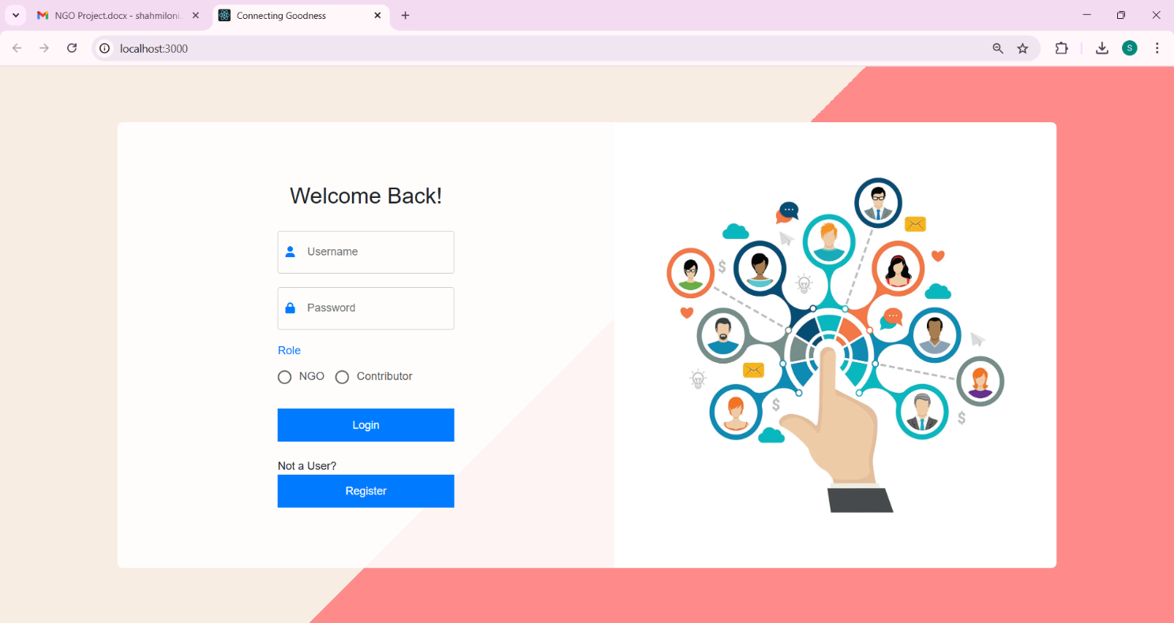

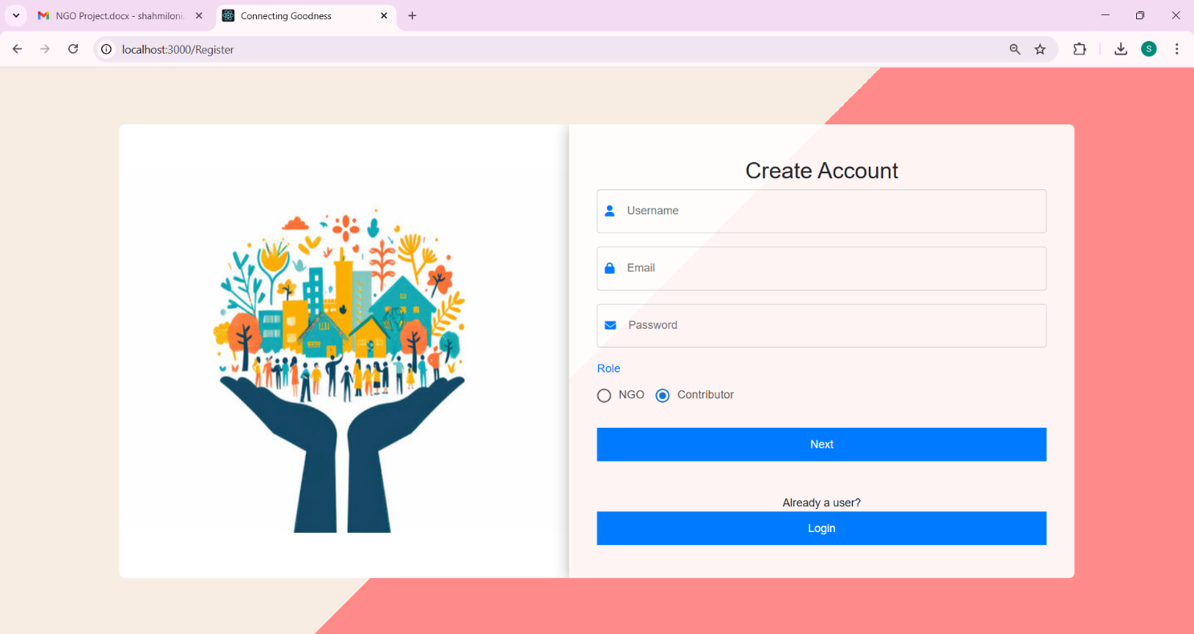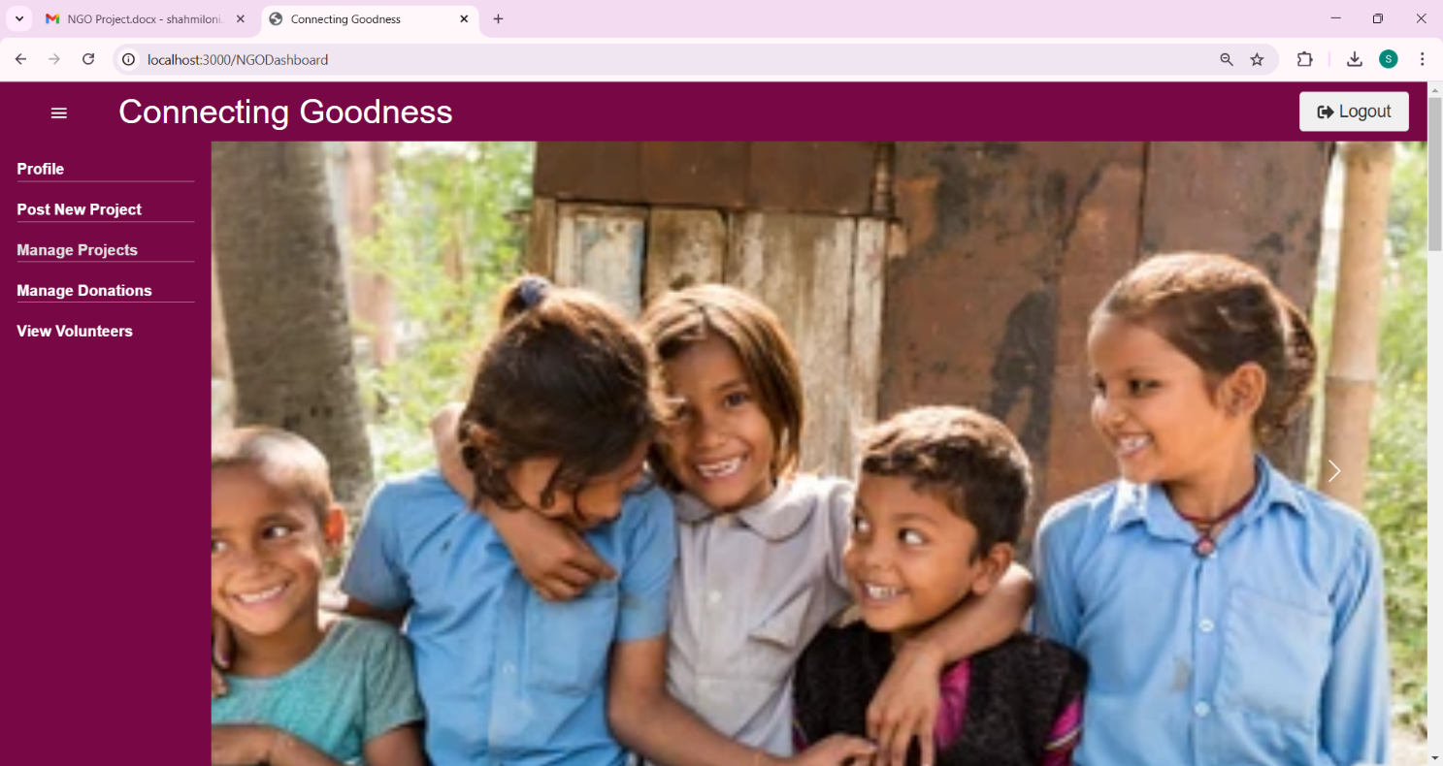

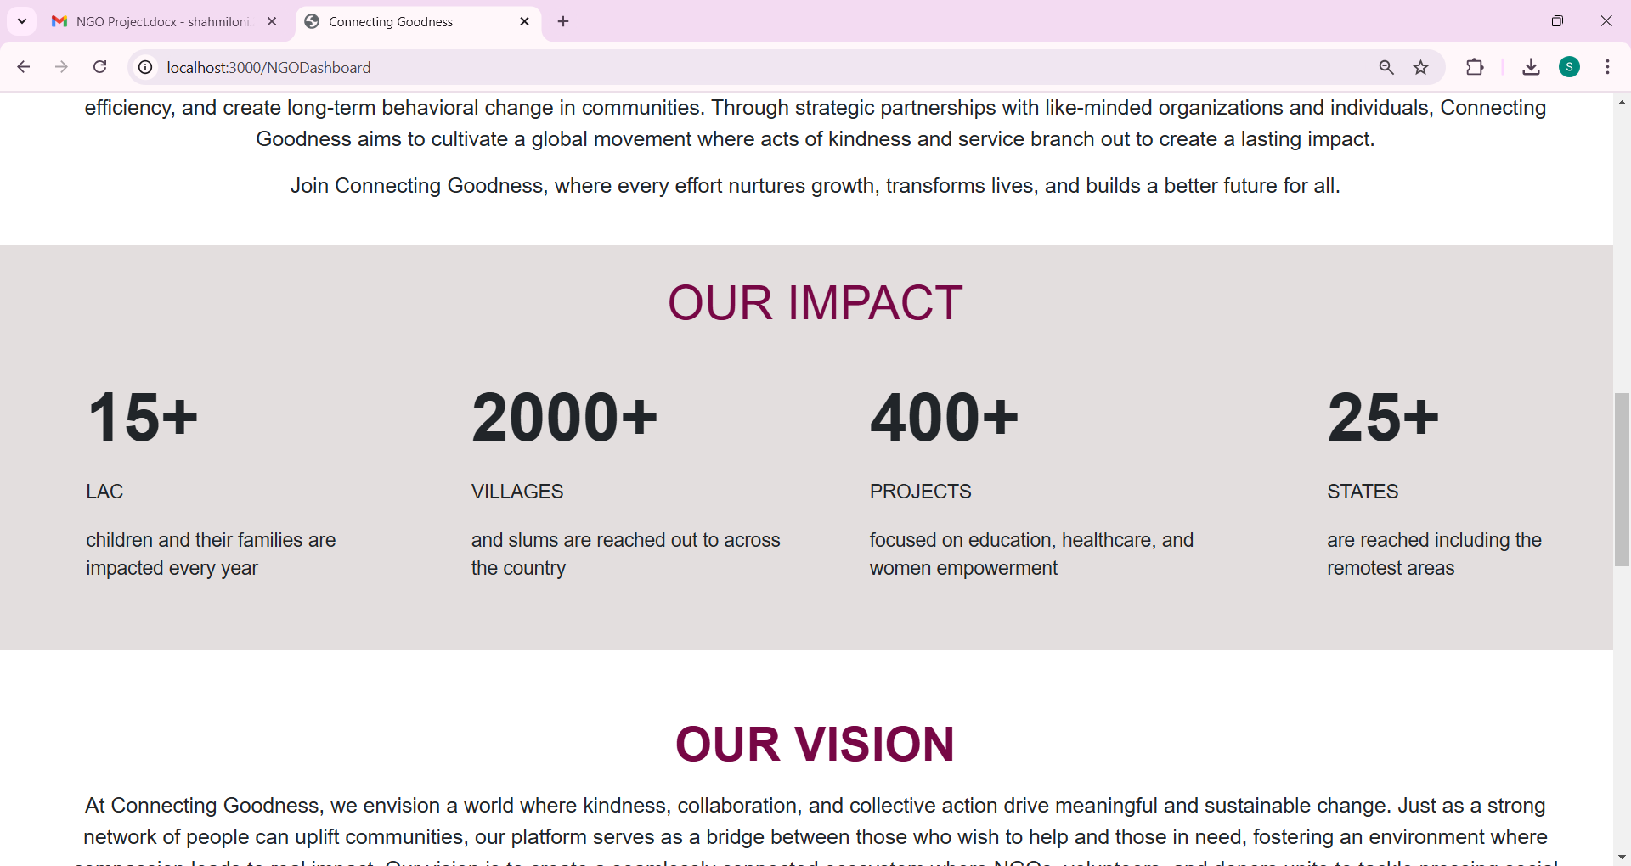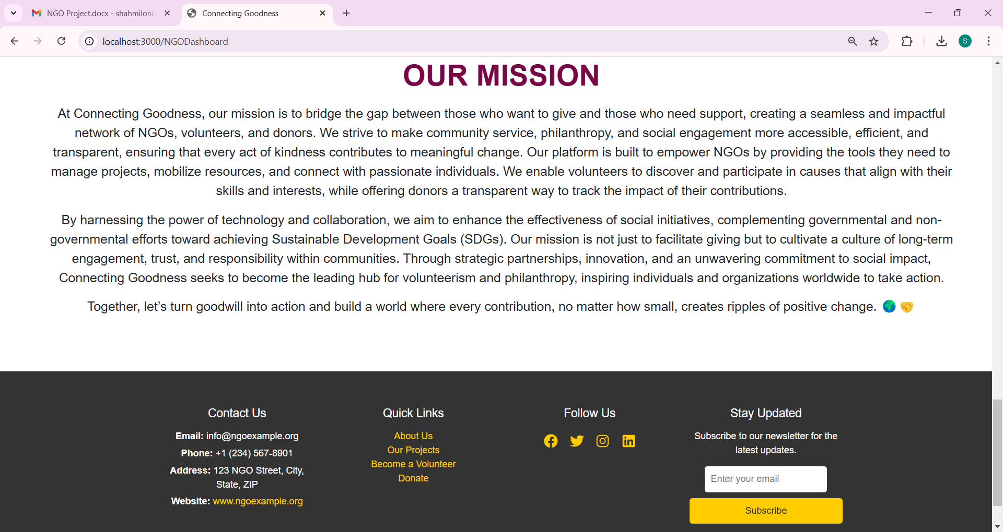

State Diagram

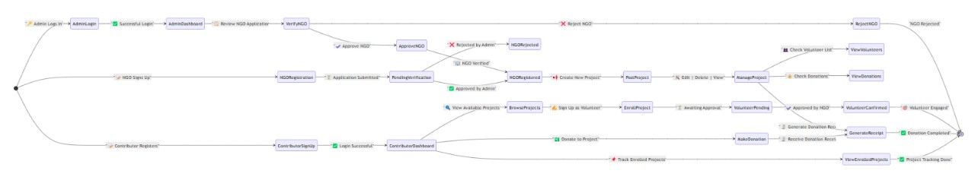

Sequence Diagram

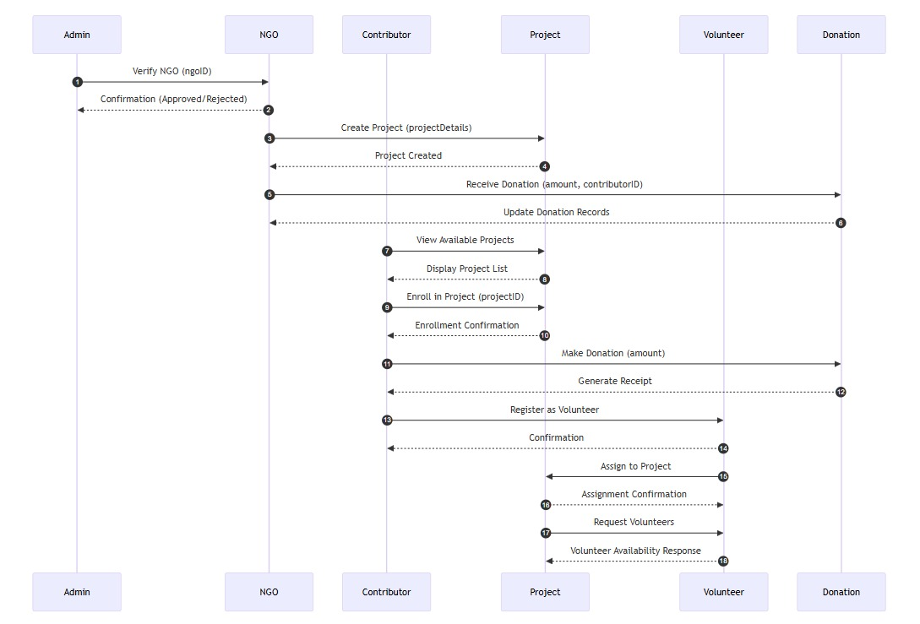

ER Diagram

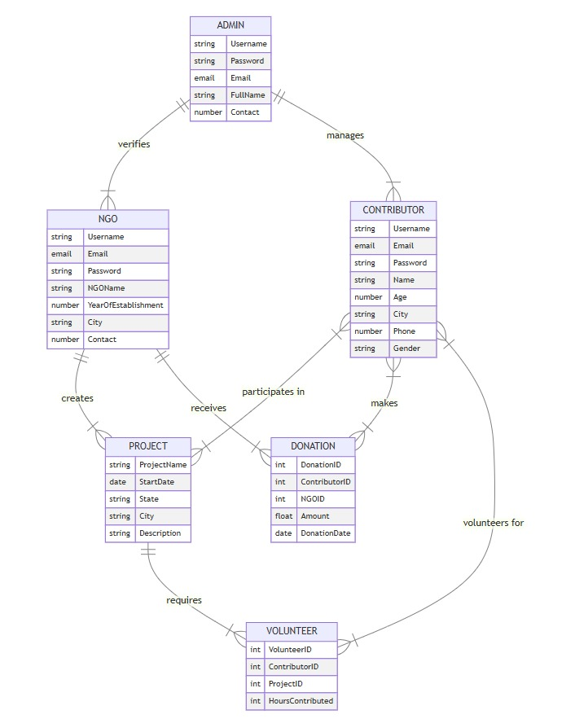

Class Diagram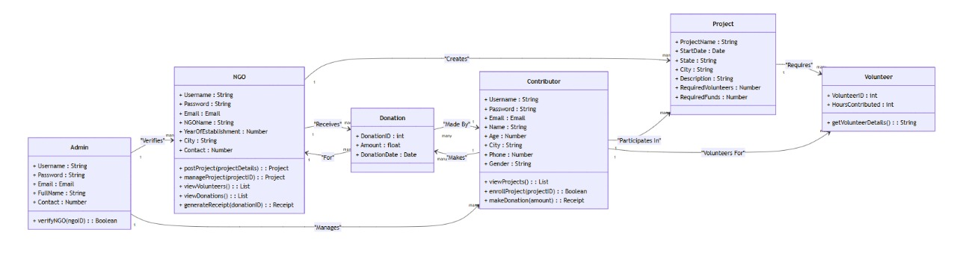

Activity Diagram

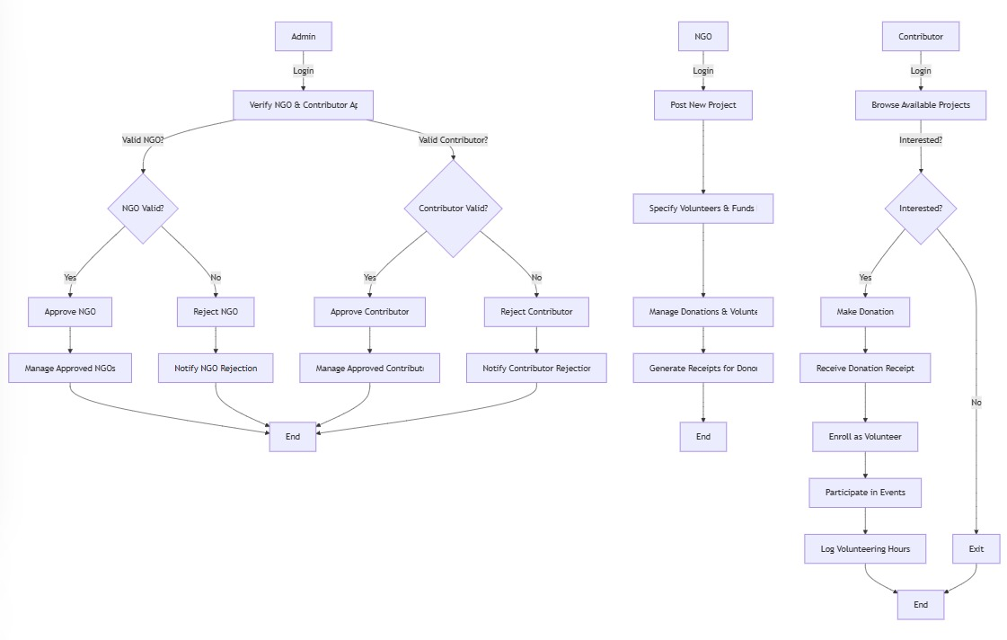

UseCase Diagram